3.4 I can set up and use permissions to filter information.

I am going to demonstrate how to invite people to collaborative technologies and get them to different roles within the project.

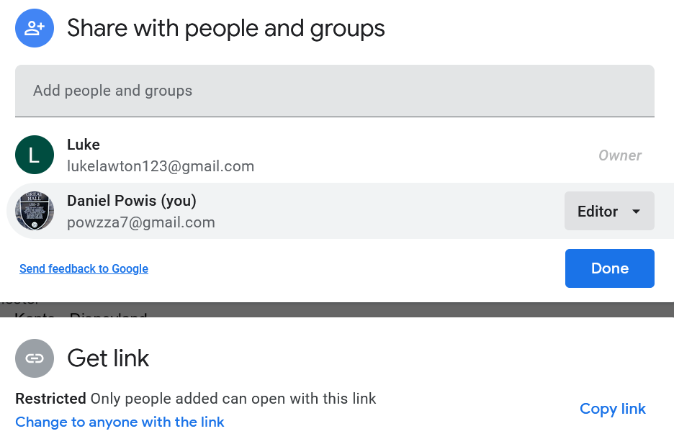

[This image shows a Google Drive account where I am apart of a collaboration]

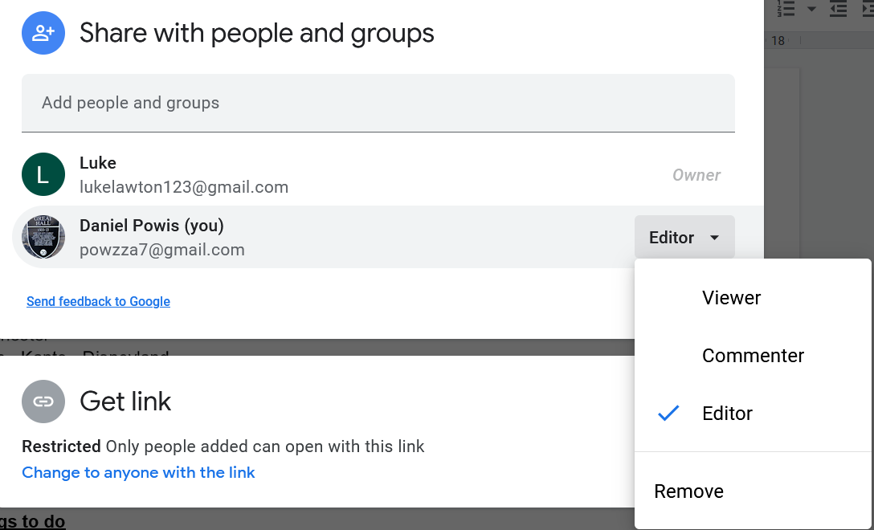

[The above image shows that I manage my own role within the collaboration]

In instances where I have made the collaboration myself I will have more options on what can be edited, for example I will reference the Wix example that I found in another piece of work:

